Technical Architecture:

Project Design Phase-II Technology Stack (Architecture & Stack)

|  |  |
| --- | --- |
| Date | 03 October 2022 |
| Team ID | PNT2022TMID07818 |
| Project Name | Project - IoT Based Safety Gadget for Child  Safety Monitoring & Notification |
| Maximum Marks | 4 Marks |

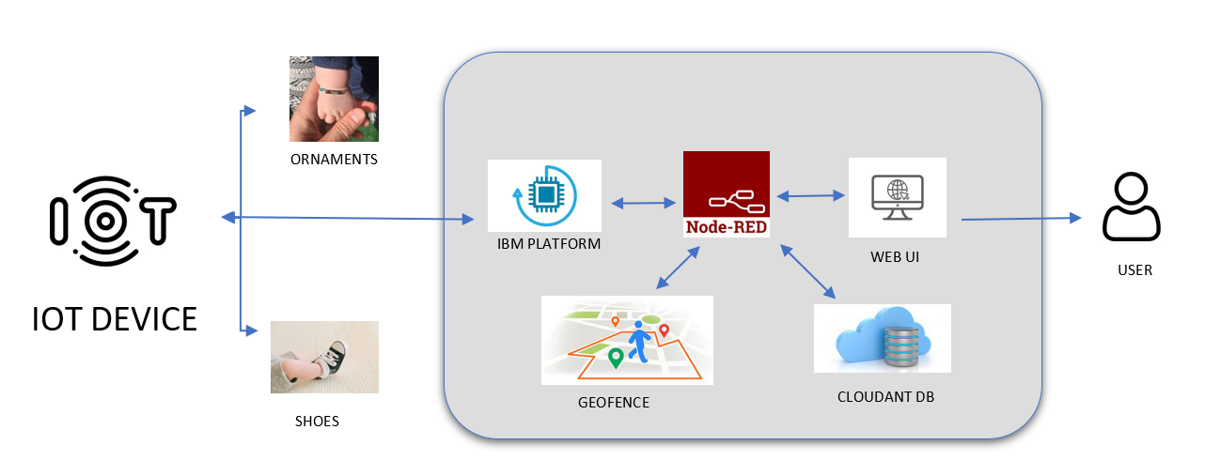

Table-1 : Components & Technologies:

|  |  |  |  |
| --- | --- | --- | --- |
| **S.No** | **Component** | **Description** | **Technology** |
| 1. | User Interface | Users react with the Application, Web UI/Chatbot. | HTML, CSS, JavaScript / Angular Js / React Js etc. |
| 2. | Application Logic-1 | Registration of children and parents details in the  application. | Python,C. |
| 3. | Application Logic-2 | Children’s device GPS should be always ON. So the location can be shared to the parents. | IBM Watson STT service, IBM Watson Assistant |
| 4. | Application Logic-3 | The information of the child’s health and location should be alerted to the parents through GSM with  the help of GPS. | IBM Watson Assistant, IBM Watson STT service, |
| 5. | Database | Data type can be of any configurations and locations are stored in the IBM cloud for future use | MySQL, NoSQL, etc. |
| 6. | Cloud Database | IBM Cloudant DB | IBM Cloudant |
| 7. | File Storage | File storage requirements | IBM Block Storage or Other Storage  Service or Local Filesystem |
| 8. | External API-1 | User to allow or give permission for the IoT device  data communication and access the child location | GPS module |
| 9. | External API-2 | To view the Location of the child and integrating  Geo-Fence with Google Maps | Google Maps |
| 10. | Machine Learning Model | For monitoring the child, its activities and with a ML model, we can easily know what’s happening to the  child and prevent any misshappenings | Object Recognition Model, State Prediction Model, Risk Management,  etc. |
| 11. | Infrastructure (Server / Cloud) | Local Server chassis: Wearable high-tech mechanism.  Cloud Server Configuration: A network that reinforces IoT devices and applications. | Cloud Foundry |

Table-2: Application Characteristics:

|  |  |  |  |
| --- | --- | --- | --- |
| **S.No** | **Characteristics** | **Description** | **Technology** |
| 1. | Open-Source Frameworks | The end users (parents/guardians) can monitor their children easily by using this proposed method. | UI/UX |
| 2. | Security Implementations | Alarm notification and continuous video recording monitoring whenever the emergency button is pressed. The wifi modules are of assistance in sending the monitoring particulars, the user will be notified with and update if any errors are found, for the efficient functioning of the device. | e.g. SHA-256, Encryptions, IAM Controls, OWASP etc. |
| 3. | Scalable Architecture | Sensor-IoT based cloud architecture | IBM cloud |
| 4. | Availability | Mobile, Laptop/Desktop and other distributed servers | MIT app |
| 5. | Performance | Checking the child location if he/she crosses the geofence. If they do, the notifications will be sent to parents/guardians. The health condition of the  children will be sent to the parent. | Temperature sensor |